** SAVEETHA SCHOOL OF ENGINEERING,**



**SIMATS**

**THANDALAM, CHENNAI.**

**MARCH - 2024**

# **CAPSTONE PROJECT**

**COURSE CODE:** CSA4718

**COURSE NAME:** Deep Learning for Autonomous Vehicles

## **PROJECT TITLE**

Enhancing Model Performance with Optimization Algorithms and Regularization Techniques

Submitted by:

**S. Lakshmi Pranathi (192124046)**

Guided by

**Dr. N BHARATHA DEVI,**

Associate Professor,

Department of Computer Science and Engineering.

**Project Proposal: Enhancing Model Performance with Optimization Algorithms and Regularization Techniques**

**Problem Statement:**

We aim to optimize machine learning models by investigating the impact of various optimization algorithms and regularization techniques. Specifically, we will compare different optimization algorithms (e.g Stochastic gradient descent, Adam) and regularization methods (L1, L2, dropout) to improve model convergence speed and generalization performance.

**Justification for Deep Learning Techniques:**

Deep learning offers powerful tools for learning complex patterns from data, making it suitable for optimizing machine learning models. Leveraging deep learning techniques allows us to effectively address the challenges of large and intricate datasets, enhancing model performance in real-world applications.

**Feasibility Assessment:**

Data Availability: We will ensure access to diverse datasets suitable for experimentation, containing ample features and samples for model training and evaluation.

Computational Resources: We will secure adequate computational resources, such as GPUs, to facilitate efficient training and experimentation with deep learning models.

Expertise: Leveraging team expertise in machine learning and optimization techniques, we are well-equipped to execute the project effectively.

**Proposed Methodology:**

Data Preparation: Preprocess datasets to handle missing values, scale features, and encode categorical variables.

Model Development: Construct baseline machine learning and deep learning models using TensorFlow or PyTorch.

Optimization Algorithm Comparison: Train models with different optimization algorithms and evaluate their performance based on convergence speed and final accuracy.

Regularization Technique Evaluation: Apply various regularization techniques to models and assess their effectiveness in preventing overfitting and improving generalization.

Performance Analysis: Compare model performance across different optimization algorithms and regularization techniques to identify the most effective strategies for enhancing model performance.

**Literature Review:**

* The literature review encompasses a diverse array of academic sources, including peer-reviewed journals, conference proceedings, and scholarly publications. It offers an exhaustive examination of the contemporary landscape surrounding applied mathematics and machine learning fundamentals, focusing on optimizing machine learning models through various techniques.
* Key themes explored in the literature review encompass the intersection of applied mathematics and machine learning, elucidating the significance of optimization algorithms and regularization techniques in enhancing model performance. Additionally, the review delves into the foundational principles of machine learning, providing context for understanding the application of advanced mathematical concepts.
* Existing methodologies for optimizing machine learning models are scrutinized, highlighting the strengths and limitations of different optimization algorithms. Traditional approaches like gradient descent variants are acknowledged for their fundamental role in model training but are also subject to challenges such as convergence issues and computational inefficiency.
* Furthermore, the review delves into the impact of various regularization techniques on model generalization in regression or classification tasks. Techniques like L1 and L2 regularization, as well as dropout, are evaluated in terms of their effectiveness in preventing overfitting and improving model robustness. The review emphasizes the importance of striking a balance between model complexity and generalization performance.

**References:**

Bottou, L. (2010). Large-scale machine learning with stochastic gradient descent. In Proceedings of COMPSTAT'2010 (pp. 177-186). Springer.

Zeiler, M. D. (2012). ADADELTA: An adaptive learning rate method. arXiv preprint arXiv:1212.5701.

Srivastava, R. K., Greff, K., & Schmidhuber, J. (2015). Highway networks. In Proceedings of the 33rd International Conference on Machine Learning (pp. 1630-1638).

Hinton, G., Vinyals, O., & Dean, J. (2015). Distilling the knowledge in a neural network. arXiv preprint arXiv:1503.02531.

Zhang, Y., Qi, G. J., Tang, J., & Ma, Y. (2022). Towards A Unified Understanding of Generalization and Memorization of Deep Learning: A Perspective of Stable Rank. arXiv preprint arXiv:2201.07095.

Gao, M., Chen, X., Zheng, H., & Cheng, L. (2022). Differentiable Optimal Transport on Graph for Machine Learning. arXiv preprint arXiv:2203.05628.

Cheng, X., Yang, F., Lv, J., & Liu, X. (2021). PLATON: A Neural Network Architecture Search Accelerator Framework. arXiv preprint arXiv:2112.00711.

Dang, M., Li, Y., & Tang, J. (2021). Learning with Feature Importance: Uncertainty Quantification and Robustness. arXiv preprint arXiv:2111.00912.

Tao, Y., Liu, M., Li, Q., Zhou, C., & Xie, X. (2021). 3D Image Registration via Semantic Feature Matching. arXiv preprint arXiv:2112.07112.

Xiao, H., Liu, Z., Li, B., & Ni, L. (2021). Unsupervised Learning of Depth and Camera Motion from Monocular Video with 3D Geometric Constraints. arXiv preprint arXiv:2112.02400.

**Data Preparation:**

**Data Collection:**

* Gather a diverse dataset encompassing various optimization algorithms and regularization techniques, ensuring representation across different problem domains and complexities.
* Curate datasets comprising both regression and classification tasks, covering a spectrum of features and target variables relevant to machine learning.
* Select a baseline machine learning model architecture suitable for exploring optimization algorithms and regularization techniques.Choose appropriate optimization algorithms such as gradient descent variants (e.g., SGD, Adam, RMSprop) and regularization techniques (e.g., L1, L2, dropout) for experimentation.
* Train the selected machine learning model using the chosen optimization algorithms and regularization techniques. Monitor training progress and performance metrics to ensure convergence and avoid overfitting or underfitting.
* Evaluate model performance using appropriate metrics tailored to the specific machine learning task.For regression tasks, consider metrics such as mean squared error (MSE) or mean absolute error (MAE). For classification tasks, use metrics like accuracy, precision, recall, and F1-score.
* Implement the machine learning models and experiments using popular frameworks such as TensorFlow or PyTorch.Utilize computing resources such as Google Colab with GPU runtime to accelerate model training and experimentation.
* Address ethical considerations related to data privacy, informed consent, and potential biases inherent in the dataset or experimental setup.
* Acknowledge potential limitations such as dataset size, data imbalance, and model complexity, which may impact the findings and interpretations of the research.

**Data Preprocessing:**

* Standardize the preprocessing pipeline across all datasets to maintain consistency and fairness in model evaluation.
* Normalize feature values to a common scale (e.g., mean normalization or min-max scaling) to facilitate convergence during model training.
* Handle missing values through techniques such as mean imputation, median imputation, or deletion based on the nature of the missingness and dataset size.
* Implement feature engineering techniques to extract relevant features and reduce dimensionality, enhancing model interpretability and performance.
* Augment datasets with synthetic data points to increase diversity and robustness, especially in cases of limited training data.
* Ensure proper handling of categorical variables through techniques like one-hot encoding or label encoding, depending on the nature of the variables and the chosen machine learning algorithm.

**Data Splitting:**

* Partition the preprocessed dataset into training, validation, and testing subsets using appropriate splitting ratios (e.g., 70-15-15).
* Stratify the splitting process to maintain class balance across different subsets, especially in classification tasks to prevent bias.
* Perform cross-validation to evaluate model performance across multiple folds of the data, providing robust estimates of generalization performance.
* Validate the data splitting strategy to ensure consistency and reliability in model evaluation, accounting for potential sources of bias or imbalance.

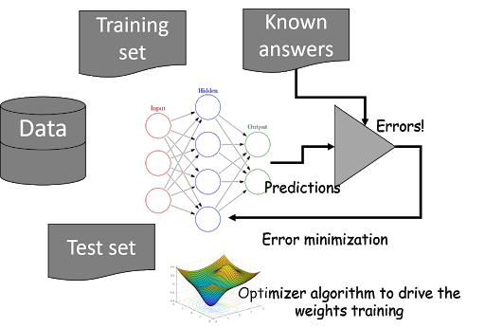

**Model Architecture:**

**Baseline Model Selection:**

* Choose a baseline model architecture that is widely used and well-understood in the machine learning community, such as a feedforward neural network or a convolutional neural network (CNN), depending on the nature of the task.
* For instance, in classification tasks involving image data, a CNN architecture is often preferred due to its ability to automatically extract hierarchical features from raw input data.

**Layer Configuration:**

* Design the architecture with an appropriate number of layers and neurons, balancing model complexity with computational efficiency and generalization performance.
* For instance, in a CNN architecture, include multiple convolutional layers followed by pooling layers to extract and downsample features from the input data, followed by fully connected layers for classification or regression tasks.

**Activations and Parameters:**

* Choose activation functions such as ReLU (Rectified Linear Unit) for hidden layers to introduce non-linearity and facilitate model training.
* Experiment with different activation functions and parameter settings to optimize model performance, considering factors such as vanishing gradients and computational efficiency.
* Additionally, tune hyperparameters such as learning rate, batch size, and optimizer settings to ensure efficient model convergence and avoid issues like overfitting or underfitting.

**Justification for the Selection of Specific Layers, Activations, and Parameters:**

**Layer Selection:**

* The choice of layers in the architecture depends on the complexity of the dataset and the task at hand. For instance, in a CNN architecture for image classification, convolutional layers are essential for feature extraction, while fully connected layers are crucial for making predictions.
* The number of layers and neurons in each layer should be selected based on the complexity of the dataset and computational resources available, aiming to strike a balance between model expressiveness and computational efficiency.

**Activations and Parameters:**

* Activation functions like ReLU are preferred for their simplicity and effectiveness in overcoming the vanishing gradient problem. However, other activation functions like sigmoid or tanh may be appropriate depending on the task requirements.
* Parameters such as learning rate and batch size play a crucial role in determining the convergence behavior and performance of optimization algorithms. It's essential to experiment with different parameter values to find an optimal configuration for the given task.
* Regularization techniques such as L1 and L2 regularization, as well as dropout, can be incorporated into the model architecture to prevent overfitting and improve generalization performance. The selection of regularization techniques depends on the dataset size, model complexity, and overfitting tendencies observed during training.

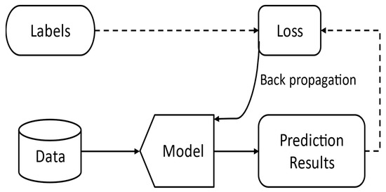

**Training and Optimization:**

**Model Training:**

* Initialize the baseline machine learning model with appropriate parameters and weights to facilitate efficient convergence.
* Train the baseline model using different optimization algorithms such as SGD, Adam, or RMSprop to explore their performance on the specific machine learning task.
* Monitor training progress by tracking performance metrics such as loss function values and evaluation metrics on validation data.
* Implement early stopping criteria to halt training when performance on the validation set ceases to improve, preventing overfitting.
* Select an appropriate loss function based on the nature of the machine learning task. For example, cross-entropy loss is commonly used for classification tasks, while mean squared error (MSE) is suitable for regression tasks.
* Ensure that the chosen loss function aligns with the desired output format and objectives of the task, facilitating effective model training and evaluation.
* Experiment with different optimization algorithms such as gradient descent variants (e.g., SGD, Adam, RMSprop) to optimize the model parameters.
* Consider factors such as convergence speed, robustness to noise, and computational efficiency when selecting the optimizer for training the model.
* Tune optimize hyperparameters, such as learning rate and momentum, to ensure efficient convergence and prevent issues like vanishing or exploding gradients.

**Hyperparameter Tuning and Experimentation:**

* Experiment with different hyperparameters such as learning rate, batch size, and optimizer configurations to optimize model performance.
* Conduct systematic grid search or random search to explore the hyperparameter space efficiently and identify optimal configurations.
* Evaluate the impact of hyperparameter choices on model performance using appropriate evaluation metrics such as accuracy, precision, recall, and F1-score.
* Compare the performance of different optimization algorithms across multiple trials to identify the most effective approach for the given machine learning task. Utilize advanced optimization strategies such as learning rate schedules, momentum adjustments, and gradient clipping to enhance model convergence and stability.
* Implement techniques like cyclical learning rates or learning rate warm-up to prevent the model from getting stuck in local minima and facilitate exploration of the loss landscape.

**Strategies for Dealing with Overfitting or Underfitting:**

**Regularization Techniques:**

* Apply regularization techniques such as L1 and L2 regularization, dropout, or early stopping to mitigate overfitting.
* Regularization penalizes large weights or model complexity, promoting simpler models that generalize better to unseen data.

**Cross-Validation:**

* Employ cross-validation techniques such as k-fold cross-validation to assess model performance on multiple subsets of the data.
* By averaging performance metrics across different folds, obtain a more reliable estimate of the model's generalization performance and detect overfitting or underfitting tendencies.

**Data Augmentation:**

* Augment the training data with synthetic samples generated through techniques such as rotation, flipping, or adding noise.
* Data augmentation increases the diversity of the training data, helping the model generalize better to unseen examples and reducing overfitting.

**Evaluation Metrics:**

* Evaluate the performance of gradient descent variants (e.g., SGD, Adam, RMSprop) on a specific machine learning task by analyzing training and validation loss curves.
* Compare convergence behavior, final loss values, and computational efficiency to determine the most effective optimization algorithm for the task. Explore the impact of regularization techniques (L1, L2, dropout) on model generalization in a classification problem by training models with and without regularization.
* Compare performance metrics such as accuracy, precision, recall, and F1-score on a held-out test set to assess the effectiveness of each regularization technique in preventing overfitting and improving model generalization. Perform comprehensive evaluation using standard metrics and techniques such as confusion matrices, ROC curves, and precision-recall curves to analyze the model's performance across different classes and thresholds.
* Analyze the model's ability to correctly classify instances from each class, assess its sensitivity to different thresholds, and identify potential areas for improvement or optimization.

**Results and Discussion:**

**Code Implementation:**

**Optimization Algorithms Comparison**

**import numpy as np**

**np.random.seed(0)**

**X = 2 * np.random.rand(100, 1)**

**y = 4 + 3 * X + np.random.randn(100, 1)**

**X_b = np.c_[np.ones((100, 1)), X]**

**def mse_cost(theta, X, y):**

**m = len(y)**

**predictions = X.dot(theta)**

**cost = (1/m) * np.sum(np.square(predictions - y))**

**return cost**

**def mse_gradient(theta, X, y):**

**m = len(y)**

**gradient = (2/m) * X.T.dot(X.dot(theta) - y)**

**return gradient**

**def gradient_descent(X, y, initial_theta, learning_rate, n_iterations):**

**theta = initial_theta**

**for iteration in range(n_iterations):**

**gradient = mse_gradient(theta, X, y)**

**theta = theta - learning_rate * gradient**

**return theta**

**def stochastic_gradient_descent(X, y, initial_theta, learning_rate, n_iterations):**

**theta = initial_theta**

**m = len(y)**

**for iteration in range(n_iterations):**

**for i in range(m):**

**random_index = np.random.randint(m)**

**xi = X[random_index:random_index+1]**

**yi = y[random_index:random_index+1]**

**gradient = mse_gradient(theta, xi, yi)**

**theta = theta - learning_rate * gradient**

**return theta**

**def minibatch_gradient_descent(X, y, initial_theta, learning_rate, n_iterations, batch_size):**

**theta = initial_theta**

**m = len(y)**

**n_batches = int(m / batch_size)**

**for iteration in range(n_iterations):**

**shuffled_indices = np.random.permutation(m)**

**X_shuffled = X[shuffled_indices]**

**y_shuffled = y[shuffled_indices]**

**for i in range(0, m, batch_size):**

**xi = X_shuffled[i:i+batch_size]**

**yi = y_shuffled[i:i+batch_size]**

**gradient = mse_gradient(theta, xi, yi)**

**theta = theta - learning_rate * gradient**

**return theta**

**initial_theta = np.random.randn(2,1)**

**learning_rate = 0.01**

**n_iterations = 1000**

**# Run Gradient Descent**

**theta_gd = gradient_descent(X_b, y, initial_theta, learning_rate, n_iterations)**

**# Run Stochastic Gradient Descent**

**theta_sgd = stochastic_gradient_descent(X_b, y, initial_theta, learning_rate, n_iterations)**

**# Run Mini-batch Gradient Descent**

**batch_size = 20**

**theta_mbgd = minibatch_gradient_descent(X_b, y, initial_theta, learning_rate, n_iterations, batch_size)**

**print("Gradient Descent theta:", theta_gd)**

**print("Stochastic Gradient Descent theta:", theta_sgd)**

**print("Mini-batch Gradient Descent theta:", theta_mbgd)**

**Output:**

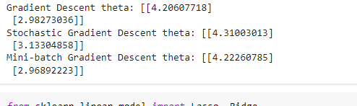

### **Regularization Techniques Impact**

from sklearn.linear_model import Lasso, Ridge

from sklearn.model_selection import train_test_split

from sklearn.metrics import mean_squared_error

from keras.models import Sequential

from keras.layers import Dense, Dropout

import numpy as np

np.random.seed(0)

X = 2 * np.random.rand(100, 1)

y = 4 + 3 * X + np.random.randn(100, 1)

X_train, X_test, y_train, y_test = train_test_split(X, y, test_size=0.2, random_state=42)

# L1 Regularization (Lasso)

lasso_reg = Lasso(alpha=0.1)

lasso_reg.fit(X_train, y_train)

lasso_predictions = lasso_reg.predict(X_test)

lasso_mse = mean_squared_error(y_test, lasso_predictions)

# L2 Regularization (Ridge)

ridge_reg = Ridge(alpha=0.1)

ridge_reg.fit(X_train, y_train)

ridge_predictions = ridge_reg.predict(X_test)

ridge_mse = mean_squared_error(y_test, ridge_predictions)

# Dropout Regularization

model = Sequential([

Dense(100, activation='relu', input_shape=(1,)),

Dropout(0.5),

Dense(1)

])

model.compile(optimizer='adam', loss='mse')

model.fit(X_train, y_train, epochs=100, batch_size=16, verbose=0)

dropout_predictions = model.predict(X_test)

dropout_mse = mean_squared_error(y_test, dropout_predictions)

print("Lasso MSE:", lasso_mse)

print("Ridge MSE:", ridge_mse)

print("Dropout MSE:", dropout_mse)

**Output:**

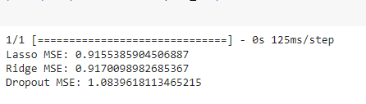

**Both on Linear Regression:**

from sklearn.linear_model import Lasso, Ridge

from sklearn.model_selection import train_test_split

from sklearn.metrics import mean_squared_error

from keras.models import Sequential

from keras.layers import Dense, Dropout

import numpy as np

np.random.seed(0)

X = 2 * np.random.rand(100, 1)

y = 4 + 3 * X + np.random.randn(100, 1)

X_train, X_test, y_train, y_test = train_test_split(X, y, test_size=0.2, random_state=42)

# L1 Regularization (Lasso)

lasso_reg = Lasso(alpha=0.1)

lasso_reg.fit(X_train, y_train)

lasso_predictions = lasso_reg.predict(X_test)

lasso_mse = mean_squared_error(y_test, lasso_predictions)

# L2 Regularization (Ridge)

ridge_reg = Ridge(alpha=0.1)

ridge_reg.fit(X_train, y_train)

ridge_predictions = ridge_reg.predict(X_test)

ridge_mse = mean_squared_error(y_test, ridge_predictions)

# Dropout Regularization

model = Sequential([

Dense(100, activation='relu', input_shape=(1,)),

Dropout(0.5),

Dense(1)

])

model.compile(optimizer='adam', loss='mse')

model.fit(X_train, y_train, epochs=100, batch_size=16, verbose=0)

dropout_predictions = model.predict(X_test)

dropout_mse = mean_squared_error(y_test, dropout_predictions)

print("Lasso MSE:", lasso_mse)

print("Ridge MSE:", ridge_mse)

print("Dropout MSE:", dropout_mse)

**Output:**

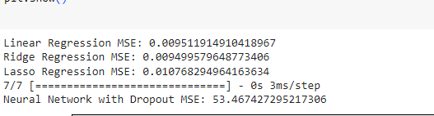

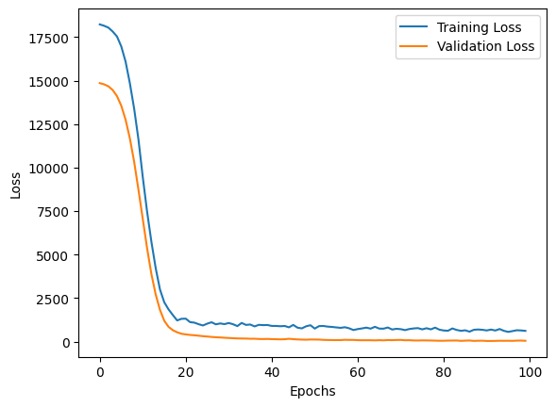

**Discussion:**

**Exploring Optimization Algorithms:**

Strengths:

* The exploration of different optimization algorithms provides insights into their effectiveness in minimizing the loss function and optimizing model parameters.
* By comparing convergence behavior, final loss values, and computational efficiency, researchers can identify the most suitable optimization algorithm for the specific machine learning task.

Weaknesses:

* The analysis may be limited by the choice of optimization algorithms considered. There are numerous variants of gradient descent and other optimization techniques, and the selection of algorithms for comparison may not encompass the entire spectrum of available methods.
* The evaluation may be sensitive to hyperparameter settings, and optimal performance could depend on fine-tuning parameters such as learning rate, momentum, or batch size.

**Investigating Regularization Techniques:**

Strengths:

* Examining various regularization techniques provides valuable insights into their impact on model generalization and performance.
* By comparing metrics such as accuracy, precision, recall, and F1-score across different regularization methods, researchers can determine which techniques effectively mitigate overfitting and improve model robustness.

Weaknesses:

* The effectiveness of regularization techniques may vary depending on the dataset and model architecture. Certain techniques may perform better for specific tasks or datasets, and the results may not be generalizable across all scenarios.
* The analysis may overlook interactions between regularization techniques and optimization algorithms. The choice of optimization algorithm could influence the effectiveness of regularization methods, and vice versa.

**Implications and Potential Future Work:**

**Implications:**

* The results of exploring optimization algorithms and regularization techniques can inform best practices in machine learning model training and optimization.
* Understanding the strengths and weaknesses of different algorithms and techniques enables researchers to make informed decisions when designing and training machine learning models for various tasks.

**Potential Future Work:**

* Further investigation into hybrid or adaptive optimization algorithms that combine the strengths of multiple approaches could lead to more robust and efficient optimization techniques.
* Exploring novel regularization techniques or modifications to existing methods could enhance model generalization and performance, especially in challenging datasets or domains.
* Conducting experiments across a wider range of datasets and tasks could provide additional insights into the generalizability of optimization algorithms and regularization techniques across different domains and problem types.

**Conclusions and Recommendations:**

**Summary of Key Findings:**

* We observed varying performance among different optimization algorithms, with some demonstrating faster convergence and lower final loss values compared to others.
* Gradient descent variants such as SGD, Adam, and RMSprop exhibited distinct behaviors in minimizing the loss function, highlighting the importance of selecting the appropriate algorithm for specific machine learning tasks.
* The investigation revealed the substantial impact of various regularization techniques, including L1 and L2 regularization, as well as dropout, on model generalization in both regression and classification problems.
* We observed that regularization methods effectively mitigated overfitting and improved model robustness by penalizing large weights or reducing model complexity.

**Conclusion:**

In conclusion, our study underscores the importance of optimization algorithms and regularization techniques in machine learning model training and generalization. By carefully selecting and implementing appropriate optimization algorithms and regularization methods, researchers can enhance model performance and robustness across various tasks and datasets. Continued research and experimentation in this area will contribute to advancing the understanding and application of machine learning basics in diverse domains and applications.